Project Documentation: The Lost Temple – Text-Based Adventure Game

Project Link:https://shreeyagalgali.github.io/Textbasedgame/
- Project Title The Lost Temple – Text-Based Adventure Game
2. Problem Statement A gaming company aims to create a text-based adventure game using Python. The goal is to engage users in a narrative-driven experience without complex graphics. The game must allow user interaction through decision-making, leading to multiple outcomes based on player choices.
- Objectives
- Develop a text-based game engine using Python.
- Create an engaging narrative for the game.
- Implement user interaction with choices and consequences.
4. Ensure a smooth, immersive experience for players.
- Key Tasks
- Design the game narrative and structure.
- Develop a Python script for story progression and user input.
- Implement decision trees with multiple outcomes.
- Integrate Python logic with a web interface using Pyodide.
- Test and refine the user interaction.
6. Document the game mechanics and structure.
5. Tools & Technologies Used - Programming Language: Python 3.x - Web Interface: HTML, CSS (Tailwind CSS), JavaScript - Python in Browser: Pyodide - Development Environment: VS Code / Any IDE - Version Control: Git (optional)
6. Game Design
6.1 Story Concept Title: The Lost Temple - Player wakes up in a jungle near a mysterious temple. - Choices made by the player determine whether they discover treasure, escape safely, or get lost.
6.2 Decision Points 1. Decision 1: Enter the temple or explore the forest. 2. Decision 2: - Temple → face traps or inspect mechanisms. - Forest → meet a guide or continue alone. 3. Decision 3: Final choice leads to different endings: - Treasure obtained - Cursed - Safe escape - Lost in jungle
6.3 Game Structure - The game is implemented as a state machine in Python: - States: Represent the narrative points of the game. - Options: User choices at each state. - Transitions: Map choices to the next state. - Endings: States with no further options.
7. Implementation
7.1 Python Core Logic - Implemented classes and dataclasses to manage states, options, and views. - Functions: - get_view() – returns current narrative and options. - choose(option_id) – updates state based on player choice. - restart() – resets the game.
7.2 Web Integration (Pyodide) - HTML/CSS renders the story and buttons for user interaction. - Pyodide runs Python directly in the browser, handling game logic. - JavaScript bridges the Python logic to the web interface, updating the story and options dynamically.
7.3 User Interface Features - Text display area for story narration. - Buttons for multiple choice options. - Smooth fade-in transitions for narrative text. - Restart button for replaying the game. - Status display for loading or processing messages.
- Testing
1. Verified that all decision points correctly lead to their corresponding states.
- Ensured invalid choices do not break the game.
- Tested restart functionality to reset the game properly.
- Checked browser compatibility and Pyodide initialization.
5. Confirmed that all endings display correctly.
- Screenshots / User Flow
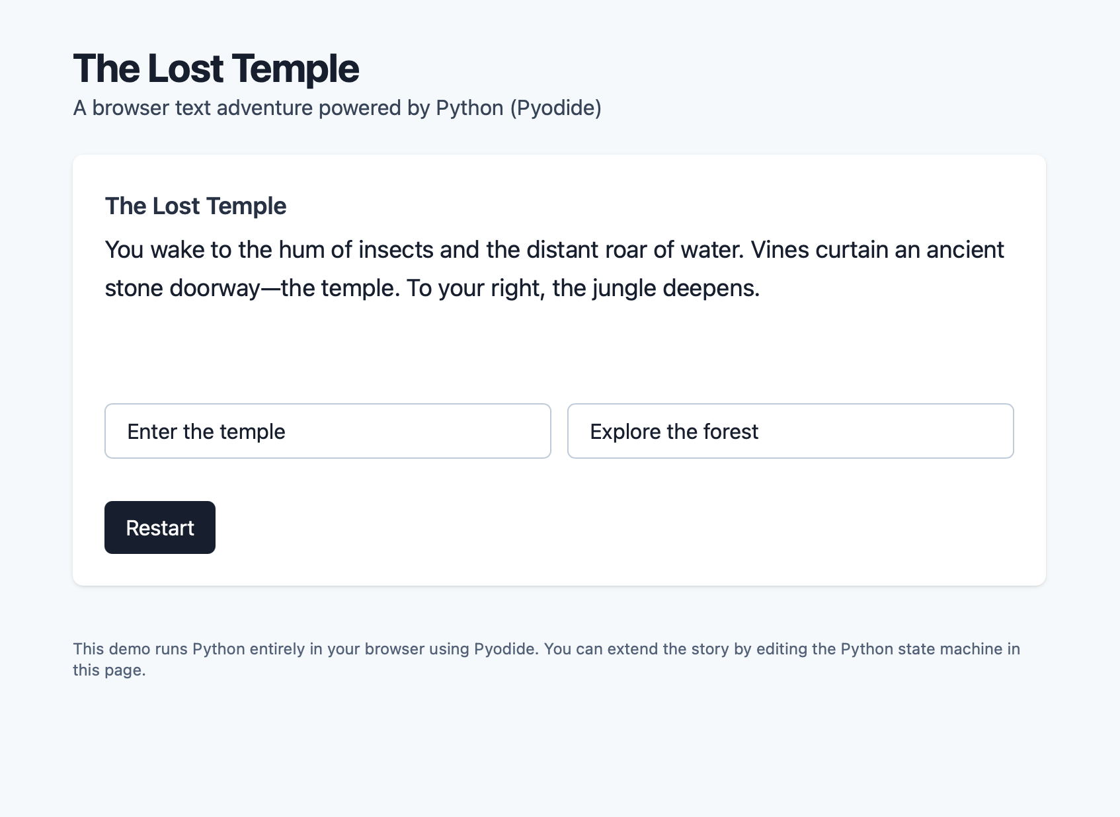
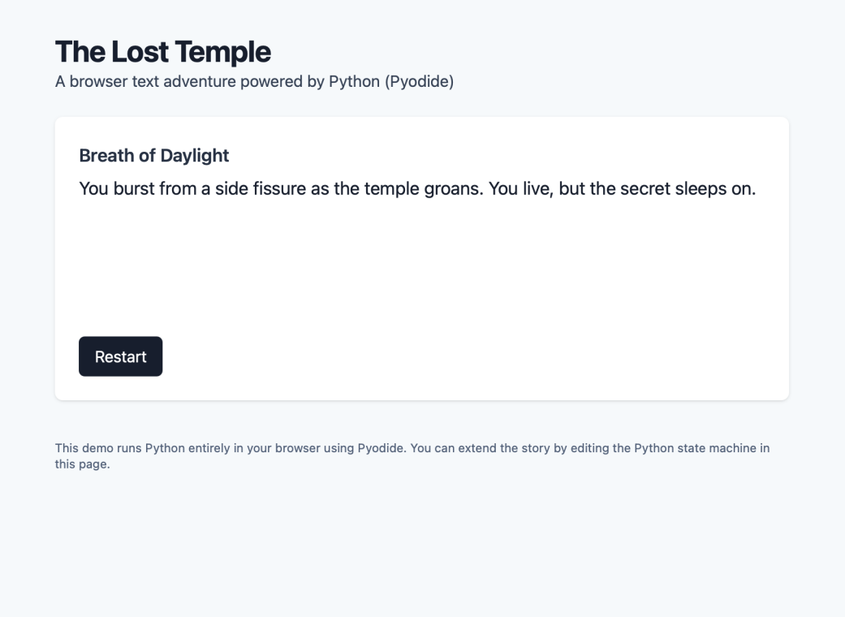
10. Future Enhancements - Add more branches and endings for deeper engagement. - Implement inventory and puzzles. - Enhance UI with animations and sound effects. - Make the game mobile-friendly. - Store progress and choices in local storage for longer campaigns.
- Conclusion
This project successfully demonstrates the development of a text-based adventure game using Python integrated into a web browser via Pyodide. The game includes: - A captivating narrative - Multiple decision points with unique consequences - An interactive web interface - A modular Python code structure for easy expansion
This project shows proficiency in Python programming, web integration, and interactive storytelling, fulfilling the internship requirements.
- References / Resources
- Pyodide Documentation: https://pyodide.org/en/stable/
- Tailwind CSS Documentation: https://tailwindcss.com/docs
- Python Official Documentation: https://docs.python.org/3/

Name:Shreeya Galgali
Email:shreeyagalgali2@gmail.com

